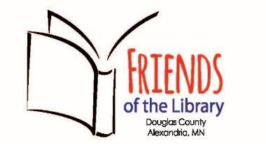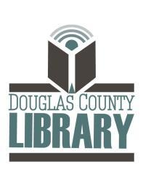

JOAN B. LARSON
FRIENDS OF THE LIBRARY SCHOLARSHIP

About the Scholarship
The Joan B. Larson Friends of the Library Scholarship is given by the Douglas County Library Friends and Foundation to two graduating seniors whose life has been positively impacted by the library. Joan B. Larson graduated from the Alexandria Public Schools in 1947 and led a long and storied career working in and supporting libraries. She was inducted into the Alexandria Public Schools Education Foundation Alumni Hall of Fame in 2015. Joan was an active member and supporter of the Douglas County Library Friends and Foundation for many years.

Scholarship Amount: $750
Number of Scholarships awarded: 2

Requirements:
- Must be a senior in high school, live in Douglas County, and be graduating this school year

Instructions:
- Please provide applicant information and answer both essay questions listed below
- Each essay answer should be between 450-500 words
- Completed scholarship applications must be received by April 6, 2024 and can be returned one of two ways:
  - Email to dclfriendsmn@gmail.com
    - OR
- Drop off/mail to the Douglas County Library, 720 Fillmore St, Alexandria - in an envelope marked – Friends of the Library Scholarship Committee

Applicant Information:
- Name: Address: Phone Number: Email Address:
- Current School attending:
- Future Plans:
- If you are awarded a scholarship, may we have your permission to post your name as a scholarship winner?

Scholarship essay questions: (450-500 words each)
- What has the Douglas County Library meant to me?
- How has the library impacted my education and future plans?

