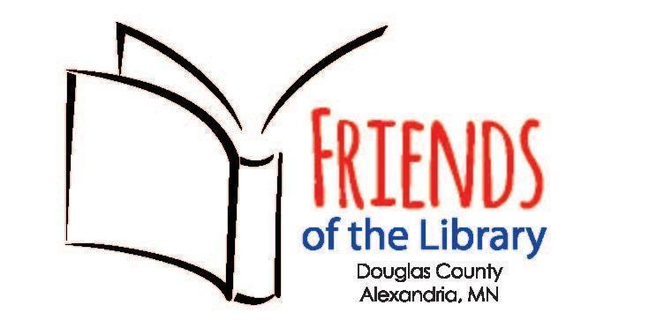

Friends of the Library Book Club
2024 Book Discussion Titles and Dates

January 22 Homecoming Kate Morton
February 26 The Night Watchman Louise Erdrich
March 25 The Children’s Blizzard Melanie Benjamin
April 22 Verity Colleen Hoover
May 20 Cilka’s Journey Heather Morris
June 24 Demon Copperhead Barbara Kingsolver
July 22 The Seed Keeper Diane Wilson
August 26 The First Ladies Marie Benedict
September 23 Sea of Tranquility Emily St John Mandel
October 28 Remarkably Bright Creatures Shelby Van Pelt
November 25 Plainsong Kent Haruf
December 16 The Stranger in the Lifeboat Mitch Albom

Discussions are held from 6:30-8:00pm in the large meeting room at the library, although there could be times we meet via Zoom due to weather.
Please contact dclfriendsmn@gmail.com for questions.

